- Though the composite PMI fell in September, it was only just below the average of the year to date and UK activity remains stronger than its peers. We remain on track for a solid outturn for GDP growth in Q3, albeit the pace is likely to fall short of the well above-trend rates seen in H1.
- Chancellor Rachel Reeves' speech at the Labour party conference opened the door for more material changes to the fiscal rules to promote investment. By talking about the need to acknowledge trade-offs, prime minister Keir Starmer continued to lay the ground for tax rises, but the net tightening of fiscal policy might not be as great as feared.
After last week's flurry of Office for National Statistics releases, the past week has been much quieter on the data front, with only a handful of business surveys to report on. The most prominent of these, the flash S&P Global survey for September, reported a steep drop in the composite PMI to 52.9 from 53.8 in August, with both sectors reporting weaker activity growth than last month.
But history suggests there's a seasonal pattern to the results and that the PMI tends to fall in September. The latest drop left the composite PMI only marginally below the average for the first nine months of the year (Chart 1). The UK's results also measure up well to its neighbours, with the eurozone composite PMI having dropped back below the 50 'no change' mark. We think the UK economy still enjoys decent momentum. With last week's strong retail sales outturn suggesting that consumer-facing sectors enjoyed a good August, we remain on track for a solid outturn for GDP growth in Q3, albeit a little short of the well above-trend rates seen in H1.
The fall in the PMI came on the back of last week's sharp drop in consumer confidence, and some commentators have argued that the gloomier mood reflects the new government's downbeat messaging on the state of the economy and the prospect of tighter fiscal policy after the Budget on October 30. The government appears to have taken this to heart, with the speech by Chancellor Rachel Reeves at this week's Labour party conference being noticeably more upbeat about the potential of the UK economy.
Chart 1: Though the composite PMI fell in September, it remained close to the 2024 average
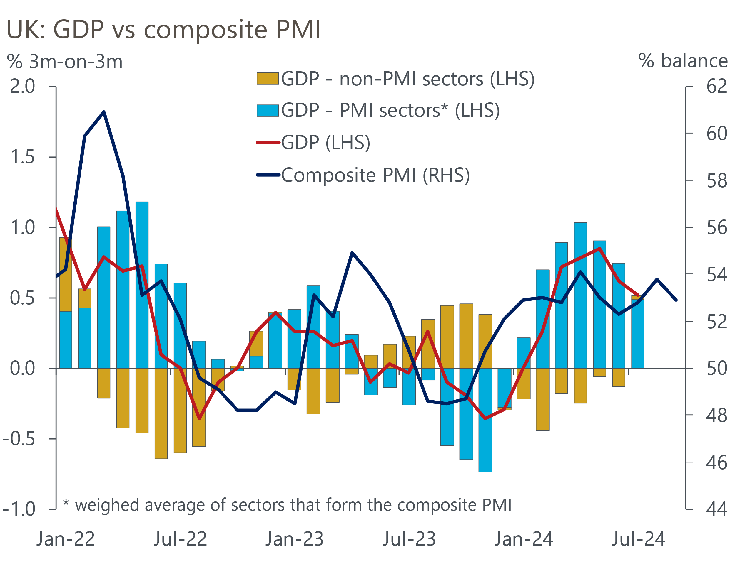
Sources: Oxford Economics, ONS, S&P Global

The main news from Reeves' speech was her vow that "it is time that the Treasury moved on from just counting the costs of investments, to recognising the benefits too". This hints at more fundamental changes to the fiscal rules than Labour had set out in its manifesto.
Before the election, Labour had promised to change the borrowing rule, targeting a balanced current budget (i.e., day-to-day spending matched to government revenue), rather than setting a limit for the broader public sector net borrowing measure. But the party had also committed to keeping the previous government's debt rule, which says that public sector net debt (excluding the Bank of England) must fall as a share of GDP in the fifth year of the Office for Budget Responsibility's forecast. Due to the impact of the Treasury's indemnity on BoE losses when it sells gilts held in its Asset Purchase Facility, the debt rule appears likely to be the binding constraint on fiscal policy throughout this parliament.
One possible interpretation of Reeves' speech was that the government might instead target public sector net worth, an idea that we've advocated. Even if that proves a step too far, PSNW might still be given greater prominence as a barometer of the government's fiscal performance. Furthermore, other options – such as targeting public sector net financial liabilities or a measure of net debt that ignores the impact of APF losses – would also potentially increase the Chancellor's room for manoeuvre (Chart 2).
Chart 2: Changing the debt rule could open a lot more fiscal headroom for the Chancellor
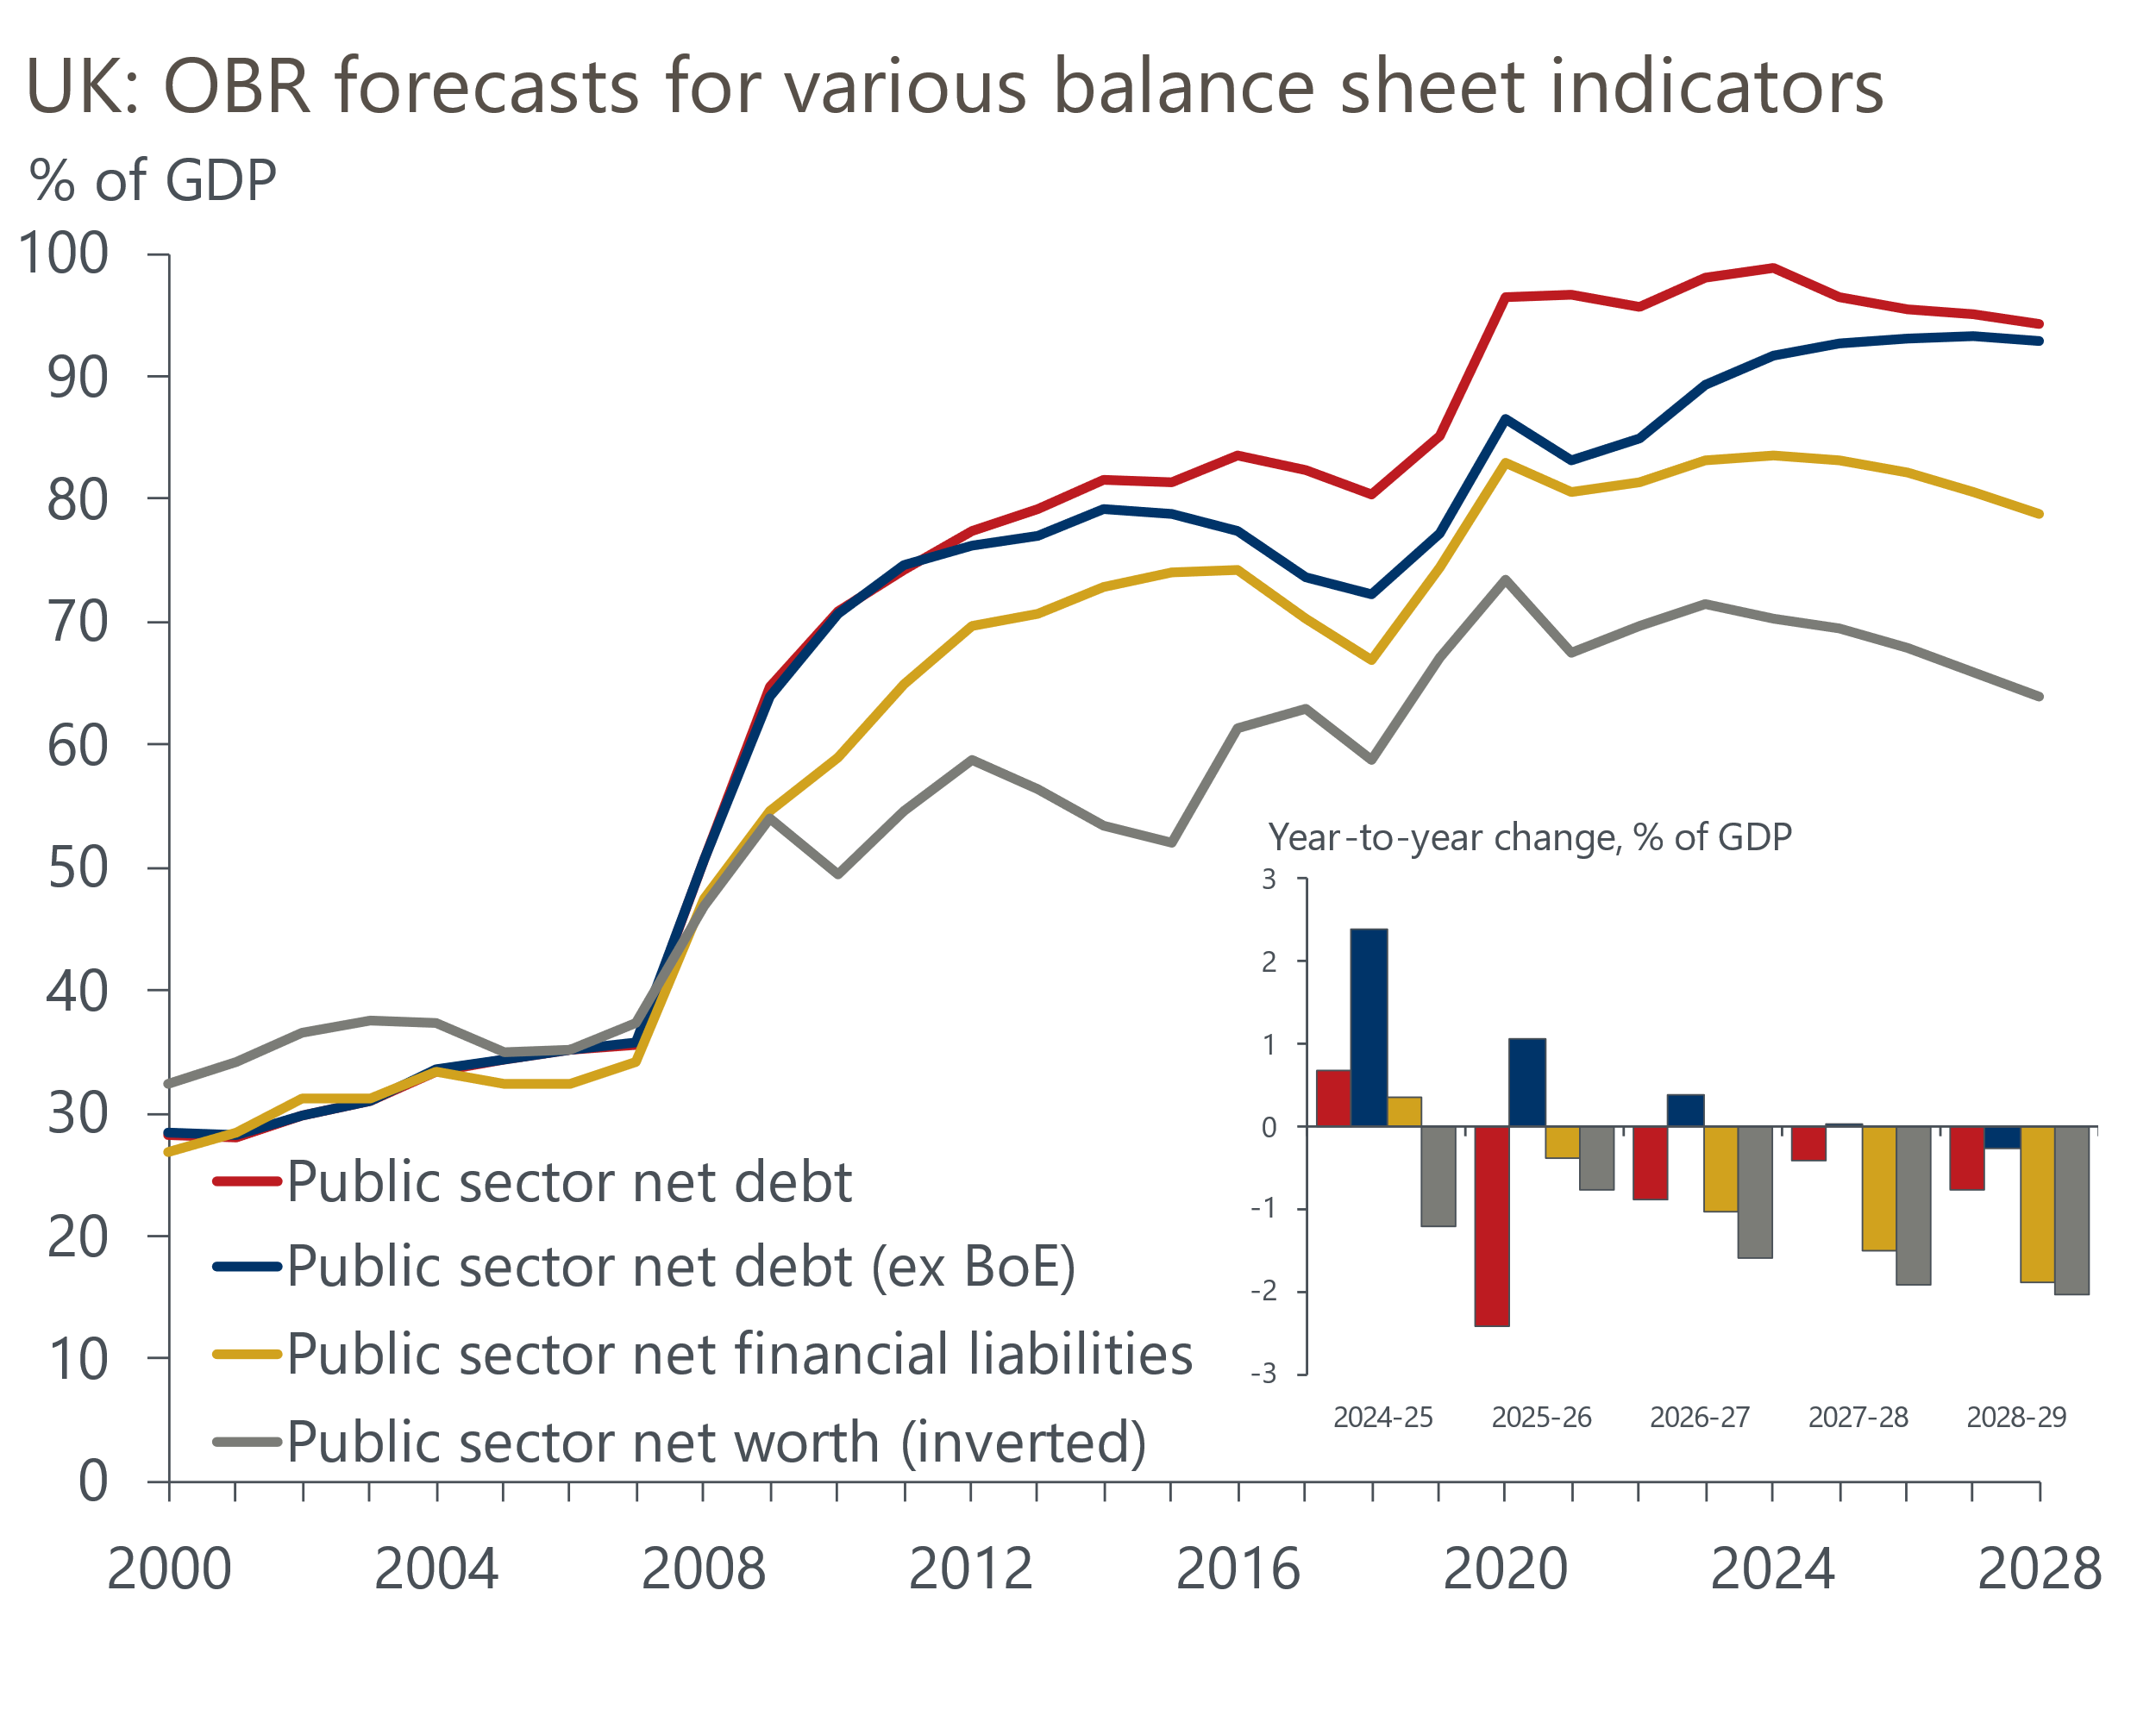
Source: OBR
Prime Minister Keir Starmer's speech focused on the idea of acknowledging trade-offs, which in terms of fiscal policy represented further confirmation that improving the funding of public services will require additional increases in taxation. But with the Chancellor seemingly more open to changing the fiscal rules to boost investment, the net tightening of policy might not be as great as feared.
Turning to monetary policy, after a very quiet summer in terms of on-the-record commentary, several members of the Monetary Policy Committee offered their views this week. In a regional visit to Kent, Governor Andrew Bailey stuck closely to the script of gradual interest rate cuts. Meanwhile, external members Megan Greene and Catherine Mann, who both voted against August's rate cut, gave speeches that drew attention to the inflation scenarios that the Bank of England has developed.
Mann subscribes to the most hawkish scenario, where recent supply shocks have caused structural changes that mean monetary policy would have to remain tighter for longer, although she did say that she considered voting for a cut in August. Greene places the greatest probability on the middle scenario, where some slack needs to open up in order to keep inflation at the 2% target over the medium-term. But she also said she sees a higher risk in the Mann scenario playing out than the most dovish one, where inflation dissipates more quickly. It looks unlikely that either external member will change their vote in the near-term, leaving the focus on the internal members to drive looser policy. The decisions announced by the Chancellor on October 30 are likely to be a key influence on the votes of the BoE insiders.

The week ahead
The Quarterly National Accounts for Q2 will incorporate the annual Blue Book revisions, as well as the rebasing of the data to 2022 prices from 2019 prices. We already know that the new data will tell us that the post-Covid recovery in 2022 was stronger than the existing time series suggests, with the level of GDP around 0.8ppts higher at the end of that year. Experience suggests there could also be large revisions for the more recent data, particularly given that the Office for National Statistics hasn't published any historical revisions to quarterly GDP estimates since June.
August's Money & Credit release is likely to report a further increase in mortgage approvals in response to the fall in quoted mortgage rates through the summer. We have pencilled in a rise in mortgage approvals to 62,500, from 62,000 in July, with the risks skewed towards a stronger outturn. But we anticipate a modest fall in net secured lending to £2.7bn. Repayments were very low in July, and we expect payback from this source to more than offset a pickup in gross lending.
On the unsecured side, there were hefty falls in both gross lending and repayments in July. We expect both to have unwound in August, with the strong increase in retail sales that month suggesting that the rebound in gross lending is likely to have been particularly strong. We forecast that net unsecured lending rose to £1.4bn from £1.2bn in July.
Next week also sees the three S&P Global surveys for September released. The flash surveys reported weaker activity growth in both services and manufacturing, and we expect the construction survey to complete a full house of softer readings.
Table 1: Week ahead calendar
Date | Events | Period | Measure | Unit | Previous | Forecast
Sep 30 | GDP | Q2 | q/q | % | 0.6 | 0.6
Sep 30 | GDP | Q2 | y/y | % | 0.9 | 0.9
Sep 30 | Mortgage approvals | Aug | Level | 000s | 62.0 | 62.5
Sep 30 | Mortgage lending | Aug | Net lending | £bn | 2.8 | 2.7
Sep 30 | Consumer credit | Aug | Net lending | £bn | 1.2 | 1.4
Oct 1 | S&P Global/CIPS manufacturing | Sep | PMI | % bal | 51.5 | 51.5
Oct 3 | S&P Global/CIPS services | Sep | PMI | % bal | 52.8 | 52.8
Oct 3 | S&P Global/CIPS composite | Sep | PMI | % bal | 52.9 | 52.9
Oct 4 | S&P Global/CIPS construction | Sep | PMI | % bal | 53.6 | 53.0
Source: Oxford Economics

Key forecasts
Table 2: UK forecast overview
(Annual percentage changes unless specified)
 | 2022 | 2023 | 2024 | 2025 | 2026 | 2027
GDP | 4.3 | 0.1 | 1.1 | 1.7 | 1.8 | 1.7
Private consumption | 4.8 | 0.2 | 0.6 | 2.1 | 2.0 | 1.6
Fixed investment | 8.0 | 2.2 | 0.3 | 0.9 | 2.5 | 2.1
Government consumption | 2.3 | 0.5 | 2.7 | 2.8 | 1.6 | 1.5
Exports of goods and services | 9.0 | -0.5 | -1.1 | 2.1 | 2.0 | 1.7
Imports of goods and services | 14.6 | -1.5 | 0.8 | 2.5 | 2.6 | 1.9
Industrial Production | -3.5 | -0.4 | -0.1 | 0.8 | 1.5 | 1.1
Consumer prices | 9.1 | 7.3 | 2.5 | 2.5 | 2.3 | 2.1
Unemployment rate (%) | 3.9 | 4.0 | 4.3 | 4.3 | 4.1 | 3.9
Current a/c balance (% of GDP) | -3.1 | -3.3 | -3.6 | -3.2 | -3.2 | -3.2
Government balance (% of GDP) | 4.2 | 5.0 | 4.0 | 3.2 | 2.5 | 1.7
Cen. bank policy rate (%, EOP) | 3.50 | 5.25 | 4.75 | 3.75 | 2.75 | 2.00
10yr govt. bond yield (%, EOP) | 3.67 | 3.54 | 3.93 | 3.67 | 3.24 | 2.85
Exchange rate (US$ per £, EOP) | 1.20 | 1.27 | 1.29 | 1.30 | 1.31 | 1.33
Exchange rate (euro per £, EOP) | 1.13 | 1.15 | 1.19 | 1.19 | 1.18 | 1.17
Source: Oxford Economics
Table 3: Quarterly forecasts for the UK
 | 2024 |  |  |  | 2025
 | Q1 | Q2 | Q3 | Q4 | Q1 | Q2 | Q3 | Q4
GDP (% year) | 0.3 | 0.9 | 1.3 | 2.1 | 1.8 | 1.6 | 1.7 | 1.7
CPI inflation (% year) | 3.5 | 2.1 | 2.1 | 2.4 | 2.5 | 2.3 | 2.7 | 2.6
Bank Rate (%, EOP) | 5.25 | 5.25 | 5.00 | 4.75 | 4.50 | 4.25 | 4.00 | 3.75
10yr gilt yield (%, EOP) | 3.95 | 4.17 | 3.95 | 3.93 | 3.87 | 3.80 | 3.74 | 3.67
US$ per £ (EOP) | 1.26 | 1.26 | 1.30 | 1.29 | 1.29 | 1.29 | 1.30 | 1.30
Euro per £ (EOP) | 1.17 | 1.18 | 1.19 | 1.19 | 1.19 | 1.19 | 1.19 | 1.19
Source: Oxford Economics

Latest Country Economic Forecast:
September 13, 2024

Recent publications

Data Insights
PMIs point to steady growth in Q3
August's retail data consolidated July's rebound in sales
Public finances leave no wiggle room ahead of Autumn Budget
August's inflation data unlikely to trigger a September rate cut
GDP flatlined for the second consecutive month in July

Research Briefings
MPC takes a breath, but cuts likely to resume in November
MPC preview – Pace of gilts sell-off is the key decision
MPC easing - how far and how fast?
Growth may slow, but the consensus looks too weak
Rate-cut cycle kicks off but it’s unlikely to be sequential

Contacts

Oxford Economics' UK team
- Andrew Goodwin - Chief UK Economist - agoodwin@oxfordeconomics.com
- Edward Allenby - UK Economist - eallenby@oxfordeconomics.com

